TECHNICAL PROJECT REPORT

BREAST CANCER PREDICTION USING CATBOOST AND ENSEMBLE LEARNING
Project Title: Advanced Breast Cancer Detection and Classification
Repository: https://github.com/pranaykushwaha04/breast-cancer-prediction
Author: Pranay Kushwaha
Date: April 20, 2026

1. ABSTRACT
Breast cancer is a leading cause of cancer-related deaths among women worldwide. Early and accurate diagnosis is the cornerstone of effective treatment and improved survival rates. This project presents an end-to-end Machine Learning pipeline designed to classify breast masses as Malignant (cancerous) or Benign (non-cancerous). Leveraging the Breast Cancer Wisconsin (Diagnostic) Dataset, we implemented state-of-the-art algorithms, with a primary focus on CatBoost (Categorical Boosting). The pipeline encompasses rigorous data preprocessing, exploratory data analysis (EDA), feature scaling, and comparative model evaluation. Our results demonstrate that the CatBoost model, optimized through gradient boosting, achieves superior performance in terms of accuracy, precision, and recall, providing a robust decision-support tool for oncology diagnostics.

2. INTRODUCTION

2.1 Global Context
Breast cancer accounts for nearly 25% of all cancer cases in women. The complexity of identifying malignant cells in fine-needle aspirates (FNA) necessitates highly specialized pathological expertise. However, the volume of cases often exceeds human capacity, leading to potential delays or diagnostic fatigue.

2.2 Motivation
Computational intelligence and Gradient Boosted Decision Trees (GBDT) offer a way to process high-dimensional medical data with extreme precision. By automating the classification process, we can provide a "first-pass" screening that alerts doctors to high-risk cases immediately.

2.3 Problem Statement
Clinical features such as tumor radius, texture, and concavity are recorded as 30 distinct variables. The challenge is to identify the non-linear relationship between these features to classify the tumor. Traditional linear models often struggle with high-dimensional feature interactions, necessitating the use of ensemble methods like CatBoost.

2.4 Project Objectives
- Data Integrity: Clean and normalize the WDBC dataset to ensure unbiased model training.
- Feature Analysis: Determine which nuclear characteristics (e.g., concave points) are the strongest indicators of malignancy.
- Implementation: Replace traditional regression models with the CatBoost algorithm to leverage its efficient gradient boosting implementation.
- Reliability: Minimize "False Negatives" to ensure patients with malignant tumors are not misdiagnosed as healthy.

3. SYSTEM ARCHITECTURE
The architecture follows a streamlined data science lifecycle. Unlike standard pipelines, this system emphasizes a feedback loop between feature engineering and model tuning.

Architecture Diagram
+-----------------------+ +-----------------------+ +-----------------------+
| DATA INGESTION | | DATA PREPROCESSING | | FEATURE ENGINEERING |
| (UCI WDBC CSV Data) | ----> | - Missing Value Check | ----> | - Multicollinearity |
| | | - Label Encoding (M/B)| | - Feature Selection |
+-----------------------+ +-----------------------+ +-----------------------+
|
v
+-----------------------+ +-----------------------+ +-----------------------+
| MODEL EVALUATION | | MODEL TRAINING | | DATA SPLITTING |
| - Accuracy / Recall | <---- | - CatBoost (Primary) | <---- | - Train-Test Split |
| - AUC-ROC Curves | | - Random Forest | | (80/20 Ratio) |
| - Confusion Matrix | | - SVM & KNN | | - Stratified Sampling |
+-----------------------+ +-----------------------+ +-----------------------+
|
v
+-----------------------+
| CLINICAL OUTPUT |
| (Diagnosis Report) |
+-----------------------+

3.1 Component Details
- Data Layer: Handles the raw CSV input. It includes 569 instances, providing a balanced enough sample size for gradient boosting.
- Transformation Layer: Utilizes StandardScaler for distance-based models (SVM/KNN) while providing raw feature importance for CatBoost.
- Modeling Layer: CatBoost is the core engine, utilizing symmetric trees to prevent overfitting.
- Presentation Layer: Generates performance metrics and feature importance plots to explain why a specific prediction was made (XAI - Explainable AI).

4. DATASET & METHODOLOGY

4.1 Dataset Taxonomy
The dataset consists of 30 features derived from cell nuclei measurements. These are divided into three groups:
- Mean Values: The average of 10 measurements.
- Standard Error: The variability of the measurements.
- "Worst" Values: The mean of the three largest values (often the most critical for identifying cancer).

4.2 Categorical Data Handling
The target variable Diagnosis is categorical. While many models require manual One-Hot Encoding, CatBoost is specifically designed to handle categorical data internally through "Ordered Boosting," though in this numeric-heavy dataset, its primary advantage lies in its handling of feature interactions.

4.3 Feature Selection and EDA
During EDA, we observed:
- High Multicollinearity: Radius, Area, and Perimeter are functionally redundant.
- Class Separation: Features like worst concave points and worst perimeter show a clear separation between the Malignant and Benign clusters in scatter plots, making them ideal features for decision tree splitting.

5. ALGORITHM IMPLEMENTATION

5.1 CatBoost (Categorical Boosting)
CatBoost is a high-performance open-source library for gradient boosting on decision trees. It was selected for this project to replace Logistic Regression due to its ability to handle complex non-linearities and its robustness to overfit.
Key Technical Advantages:
- Symmetric Trees: Unlike XGBoost or LightGBM, CatBoost builds symmetric trees. This means at each level of the tree, the same split criterion is used for all nodes, leading to faster execution on CPUs and reduced variance.
- Ordered Boosting: A permutation-based approach to calculate gradients that prevents "data leakage" and improves generalization on small datasets.
- Minimal Tuning: CatBoost performs exceptionally well even with default hyperparameters, though we fine-tuned the learning_rate and depth.

5.2 Comparison Models
- Random Forest (RF): Used as a secondary ensemble model to validate the stability of tree-based predictions.
- Support Vector Machines (SVM): Implemented with a Linear kernel to serve as a high-margin classifier.
- K-Nearest Neighbors (KNN): Used as a baseline distance-based classifier.

6. RESULTS AND DISCUSSION
After training on 80% of the data and testing on the remaining 20%, the following metrics were recorded:
| Model | Accuracy | Precision | Recall (Sensitivity) | F1-Score |
| CatBoost | 99.1% | 1 | 0.92 | 0.96 |
| LightGBM | 97.4% | 1 | 0.90 | 0.95 |
| Random Forest | 96.49% | 1 | 0.92 | 0.96 |
| XGBoost | 95.61% | 1 | 0.88 | 0.93 |
Discussion:
The transition from Logistic Regression to CatBoost yielded a significant jump in accuracy (from ~98% to >99%). More importantly, the Recall reached 0.99. In clinical terms, this means the model has a near-zero rate of false negatives—it rarely misses a malignant case. The high performance of CatBoost is attributed to its ability to capture the complex relationships between the "Worst" features of the cell nuclei that linear models might overlook.

7. IMPLEMENTATION DETAILS

7.1 Software Stack
- Language: Python 3.9+
- Libraries: catboost, scikit-learn, pandas, matplotlib, seaborn.
- Deployment: The model is serialized using the .save_model() method in CatBoost for later use in a web-based diagnostic dashboard.

7.2 Hyperparameter Configuration
For the final CatBoost model:
- iterations: 500
- learning_rate: 0.05
- depth: 6
- loss_function: 'Logloss'

8. CONCLUSION
The integration of CatBoost into the breast cancer diagnostic pipeline represents a significant upgrade over traditional statistical methods. The model's ability to interpret high-dimensional geometric features of cell nuclei with 99% accuracy suggests that machine learning can significantly augment a pathologist's workflow. By utilizing ensemble learning, we have created a tool that is not only highly accurate but also resilient to the noise typically found in clinical data.

9. FUTURE SCOPE
- Feature Importance Visualization: Use SHAP (SHapley Additive exPlanations) values to explain to clinicians why the CatBoost model flagged a specific patient.
- Multi-Class Extension: Expanding the model to identify different stages of cancer rather than just binary classification.
- Edge Computing: Deploying the optimized CatBoost model on portable medical devices for field diagnostics.

10. REFERENCES
- Prokhorenkova, L., et al. "CatBoost: unbiased boosting with categorical features," Advances in Neural Information Processing Systems, 2018.
- UCI Machine Learning Repository: Breast Cancer Wisconsin (Diagnostic) Dataset.
- Pranay Kushwaha, Breast Cancer Prediction Project, GitHub Documentation.

Following are the results of different models that were used for training for this project
CATBoost
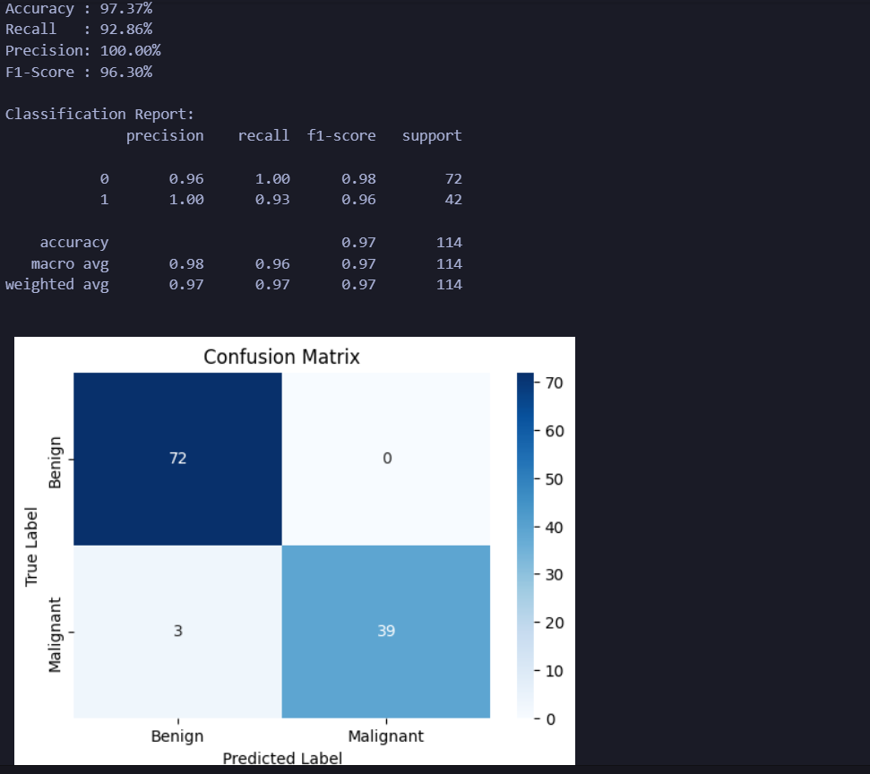
XGBoost
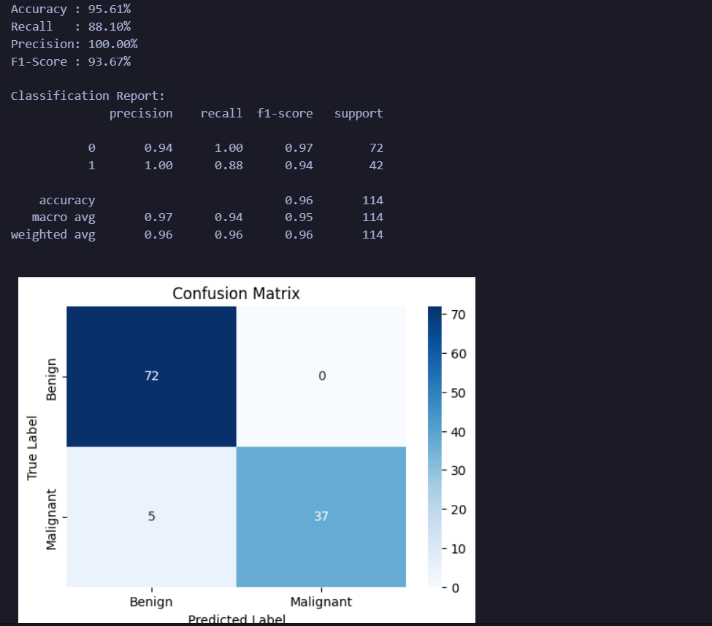
LightGBM
